OS Assigment-3 | SimpleScheduler: A Process Scheduler in C from Scratch
Group ID-16
Members: Vaibhav Samrat Waghaye | 2024597, Rigzin Gyalpo | 2024458
Contributions:
Vaibhav-> Scheduler,Simple shell update, fib file
Rigzin-> Scheduler, Simple shell update,dummy files
Implementation:

This assignment involved building a simple process scheduler in C that simulates round-robin CPU scheduling. The system consists of two main components: a shell (SimpleShell) that accepts job submissions from the user, and a separate scheduler process (SimpleScheduler) that manages the execution of these jobs.
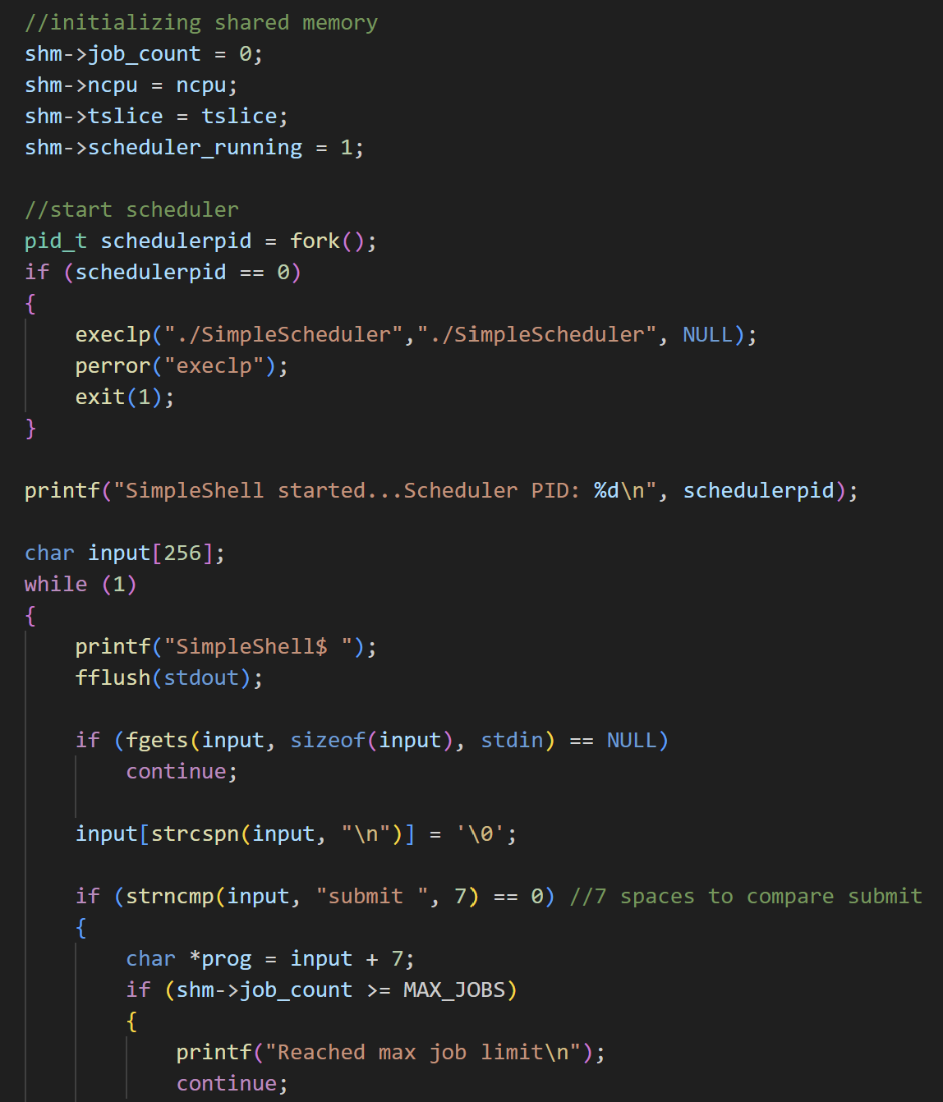

The scheduler takes the number of available CPUs (NCPU) and the time quantum (TSLICE) as input, and schedules submitted jobs fairly across the CPUs using a round-robin policy. It uses shared memory for coordination between the shell and scheduler, and UNIX signals to control the start and stop of processes. The scheduler continues running in the background, handling jobs until all have completed and the shell exits.
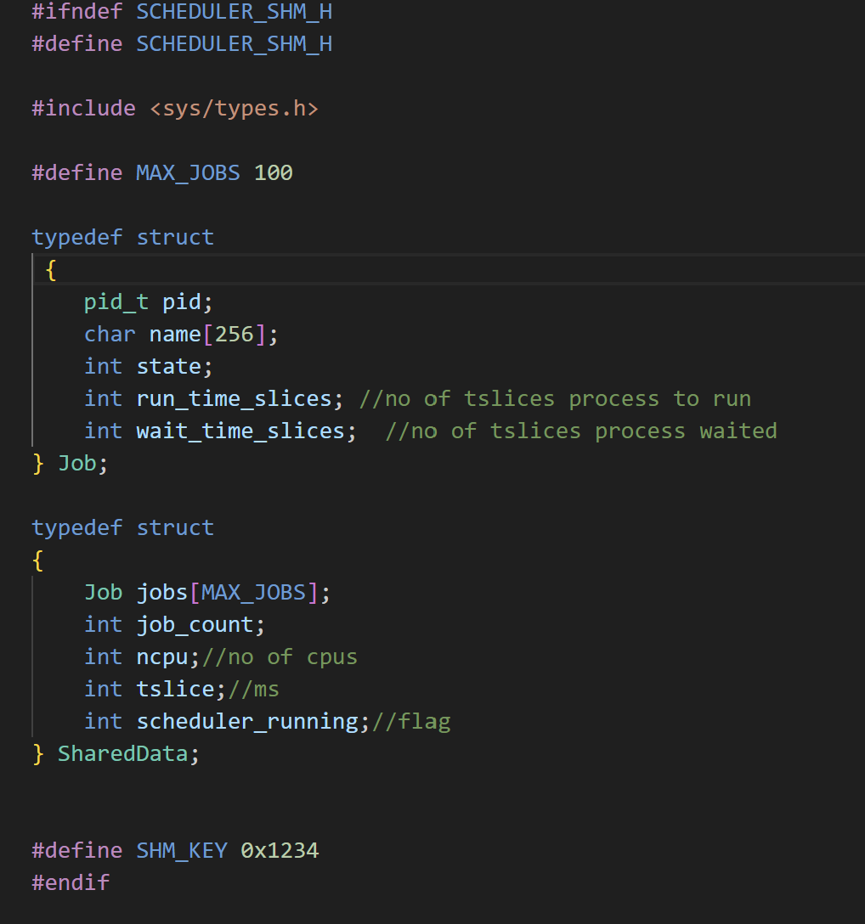

We can run the following fib file and get the value-
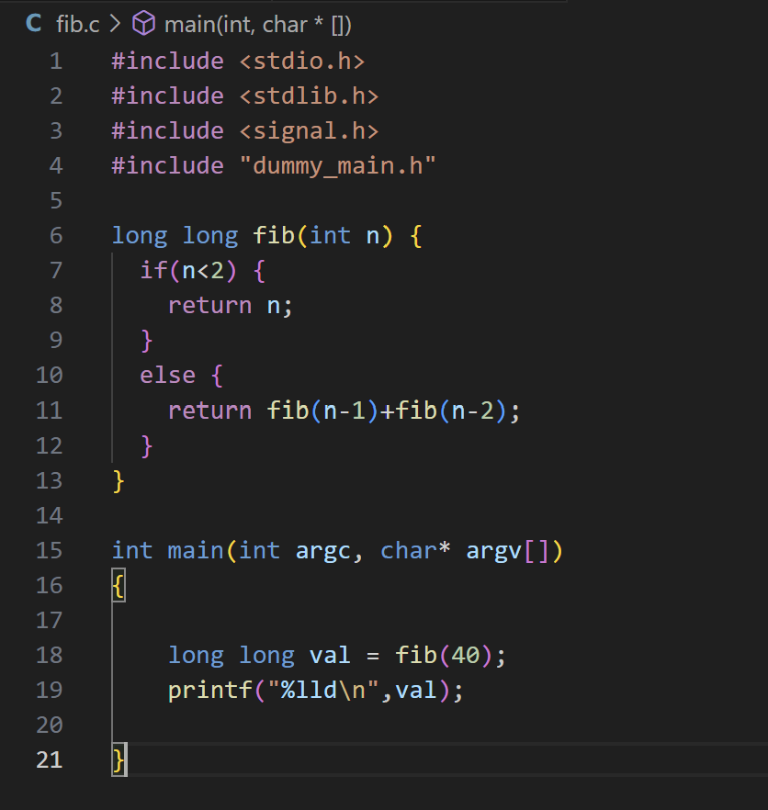

GitHub Repository Link: https://github.com/vaibhavsw27/group-16-A3

